Epsom & Ewell F.C.
21
v
Badshot Lea F.C.
Saturday, 4th February 2017 – 3.00 p.m.
Good afternoon! We welcome the players, supporters and officials of Badshot Lea Football Club, today’s officials and our own regular people for today’s League match.

We have already met once this season, winning 4-1 at Ash United in September and it has to be said, their plight this season is a serious one. With a new ground hopefully not far away for them, it would be a big disadvantage should they be relegated, but with three teams almost certainly going down this year, they have plenty of work to do.

We were due to be here on Saturday 21st January but the match against Bedfont & Feltham was postponed and we will host them now on Tuesday 7th March. We then were due to visit CB Hounslow United, but a sudden drop in temperatures led to a late postponement.

There is a school of thought going round, led notably by Tony Incenzo the well-known non-league football authority, that if in doubt, a match should be postponed early, but I personally believe that if there is a chance to play then we should hold on as long as possible. It is not such an issue this year as the weather has been largely kind but in 2012/13 for example, the enormous backlog led to lots of problems. Playing three or four times a week at the end of a tiring season is surely far more inconvenient than the occasional journey for a late postponement which happens very rarely. I accept that this is a slightly more difficult prospect for clubs and their people who have to travel the length of the country, but most regular travelling supporters are having a day out with the football as a part of it, especially on a Saturday. They’ll find other ways to be occupied if a game is off, and as I say, they would find the occasional late postponement preferable to a number of expensive midweek away trips in a cluster at the end of April.

Prior to those matches, we hosted Guildford City, who made the second of their two visits in seven days, this time for a League match, and a Craig Hastings header gave us the three points from a 1-0 win. It was a deserved win and maybe we should have killed the game off sooner but they rarely threatened us at the back. It was also nice to get revenge for the Surrey Senior Cup defeat!

On Saturday we were robbed by a late penalty at A.F.C. Hayes after dominating but not taking our chances, although on Tuesday we produced a much improved performance to win 3-1 at Walton & Hersham and reach the Semi-Final of the League Cup. We conceded early but fought back well and could have won by more in the end. The Semi-Final draw has not been made yet.

Please note that our visit to Bedfont Sports on Tuesday is OFF as their new 3g surface is not ready yet. Our next match will be at Chertsey Town on Saturday and we visit CB Hounslow United on Tuesday 14th February, returning here for the visit of Westfield two weeks today.

Enjoy the game!

Rich

You can follow us on Facebook: www.facebook.com/epsomandewellfc
Twitter: @EEFCOfficial Instagram at: www.instagram.com/epsomandewellfc
and on Youtube at: www.youtube.com/channel/UCtLrpS0x5OaYUACRT34_zng

Today’s Cover Photos

- Craig Hastings heads our winner against Guildford City in our previous home match

- Matt Farrell scores our third goal in a 4-1 win at Badshot Lea in September 2016

Cherry Red Records Combined Counties League
Premier Division Table 2016/17
inc Wednesday 1st February | P | W | D | L | F | A | Pts | GD | H | A
Hartley Wintney | 31 | 26 | 3 | 2 | 107 | 31 | 81 | +76 | 18/3 | 1-3
Westfield | 29 | 18 | 7 | 4 | 66 | 33 | 61 | +33 | 18/2 | 1-2
Hanworth Villa | 30 | 17 | 5 | 8 | 51 | 33 | 56 | +18 | 2-2 | 0-1
Horley Town | 28 | 15 | 5 | 8 | 64 | 44 | 50 | +20 | 3-0 | 17/4
Walton & Hersham | 28 | 13 | 11 | 4 | 46 | 29 | 50 | +17 | 4/3 | 1-1
Camberley Town | 28 | 15 | 4 | 9 | 59 | 32 | 49 | +27 | 0-0 | 1/4
Epsom & Ewell | 28 | 13 | 7 | 8 | 59 | 39 | 46 | +20 | X | X
Knaphill | 28 | 14 | 3 | 11 | 57 | 52 | 45 | +5 | 4-0 | 8/4
Abbey Rangers | 29 | 12 | 5 | 12 | 49 | 53 | 41 | -4 | 7-1 | 20/2
Windsor | 30 | 11 | 7 | 12 | 57 | 52 | 40 | +5 | 2-0 | 1-2
Bedfont Sports | 27 | 11 | 6 | 10 | 47 | 52 | 39 | -5 | 5-1 | tba
Guildford City | 32 | 11 | 6 | 15 | 62 | 69 | 39 | -7 | 1-0 | 2-0
Spelthorne Sports | 29 | 11 | 5 | 13 | 52 | 55 | 38 | -3 | 3-2 | 25/2
AFC Hayes | 30 | 10 | 6 | 14 | 48 | 56 | 36 | -8 | 2-2 | 0-1
Colliers Wood United | 26 | 9 | 8 | 9 | 43 | 43 | 35 | 0 | 14/4 | 0-5
North Greenford United | 26 | 10 | 4 | 12 | 53 | 51 | 34 | +2 | 22/4 | 1-2
CB Hounslow United | 28 | 10 | 3 | 15 | 42 | 57 | 33 | -15 | 1-5 | 14/2
Farnham Town | 29 | 9 | 5 | 15 | 42 | 59 | 32 | -17 | 25/3 | 2-1
Chertsey Town | 29 | 8 | 6 | 15 | 38 | 69 | 30 | -31 | 2-1 | 11/2
Sutton Common Rovers | 24 | 8 | 4 | 12 | 34 | 44 | 28 | -10 | 2-1 | 1-1
Raynes Park Vale | 29 | 5 | 7 | 17 | 36 | 62 | 22 | -26 | 1-1 | 1-1
Badshot Lea | 29 | 5 | 4 | 20 | 36 | 80 | 19 | -44 | 4/2 | 4-1
Bedfont & Feltham | 29 | 4 | 5 | 20 | 36 | 89 | 17 | -53 | 7/3 | 9-2

Lucky Day? – 4th February
Played 16 - Won 8 Drawn 3 Lost 5 - For 32 Against 26 - PPG 1.69 - Above Average
Our Club record against today’s opponent
Played 18 - Won 8 Drawn 3 Lost 7 - For 35 Against 34 - PPG 1.67 - Above Average
Our Largest wins and losses against today’s opponent
9th April 2016 - Won 4-1 - Combined Counties League (H)
17th September 2016 - Won 4-1 - Combined Counties League (A)
2nd October 2010 - Lost 0-4 – Combined Counties League (A)
Their Last Visit
9th April 2016 - Won 4-1 - Combined Counties League

Congratulations Skipper!
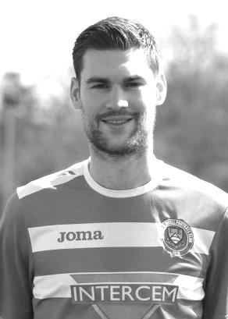
On Saturday at A.F.C. Hayes, our Captain Dan Dean made his 100th appearance in Epsom colours. Unfortunately a late penalty ruined any chance of a great result to go with it.

Dan made his debut for us on 2nd August 2014 as did many others in our 2-0 win at Farnham Town on the opening day of that season and he has been a regular for us in that time, taking over the Captaincy from Sam Currie over a season ago now.

Dan is a versatile player, regularly playing in defence but also in midfield . His former clubs include Fulham, AFC Wimbledon, Leatherhead Walton & Hersham, Merstham and latterly Chipstead, from where he joined us.

Congratulations Deano and here’s to many more!

Birthday Corner
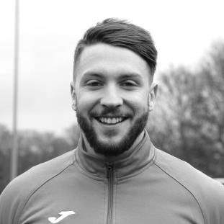
We have a few birthday celebrations for January, starting with Ali Turpie. Our keeper was 25 on Saturday 7th January. Ali has been a useful back up this season and last, since joining us from EIS Pearl CFC, playing out of Doha, Qatar in the Qatari Third Division! I wonder if he still has any contacts there as I note they are sponsored by Etihad Airways and it would be nice to pick up a little sponsorship……! Ali (left) currently has eleven appearances for us with four clean sheets.

A day later on 8th January, our striker Rob Hendry (right) celebrated his 27th birthday. He had plenty to celebrate, scoring the day before in our win over Spelthorne Sports and this is a chap that likes to celebrate! His “achievements” whilst in Chantilly in June are almost legendary as was his ability to then score two goals in our 5-2 defeat the very next day!

Rob currently has made 76 appearances with 19 goals for the club.

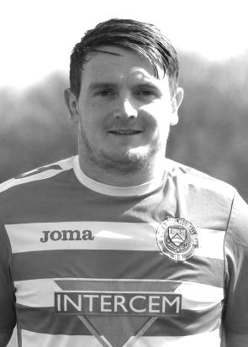
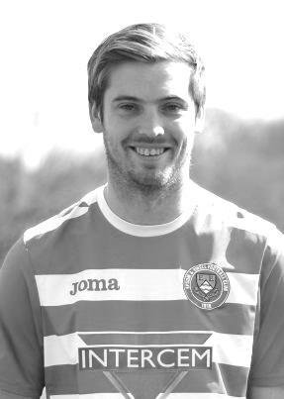
On Wednesday 11th January Elliott Thompson had his 26th birthday. Elliott joined us towards the end of last season and had secured a starting eleven position when we kicked off this term. However, a nasty knee injury at Windsor on 13th August ended his season almost before it had begun and it will be some time yet before we see him back in Epsom colours.

I am always particularly impressed when players who are unable to play for whatever reason, still come along to support the club and Elliott is very often seen at home and away games. At the time of the injury Elliott had made 16 appearances with just the one goal, scored against Bedfont & Feltham in our 9-2 win over there.

Finally, on 21st January I celebrated my 50th birthday! The frost denied me a comfortable home win for my birthday present!

Latest Results and Fixtures
Combined Counties League – Tuesday 17th January
Epsom & Ewell | 1-0 | Guildford City
Farnham Town | 1-1 | Walton & Hersham
Horley Town | 3-2 | Bedfont & Feltham
Combined Counties League – Saturday 21st January
CB Hounslow United | 1-0 | Farnham Town
Hartley Wintney | 5-1 | Chertsey Town
Combined Counties League – Tuesday 24th January
Spelthorne Sports | 3-2 | Badshot Lea
Combined Counties League – Saturday 28th January
AFC Hayes | 1-0 | Epsom & Ewell
Badshot Lea | 2-2 | Bedfont Sports
Bedfont & Feltham | 2-7 | Hartley Wintney
Camberley Town | 3-0 | Horley Town
Chertsey Town | 1-0 | CB Hounslow United
Farnham Town | 2-2 | Windsor
Guildford City | 1-4 | Spelthorne Sports
Raynes Park Vale | 2-1 | Knaphill
Sutton Common Rovers | 4-2 | North Greenford United
Westfield | 3-1 | Walton & Hersham
Surrey Senior Cup – Third Round – Tuesday 31st January
Tooting & Mitcham United | 0-1 | Knaphill
Combined Counties League Cup QF – Tuesday 31st January
Walton & Hersham | 1-3 | Epsom & Ewell
Windsor | 2-0 | Horley Town
Combined Counties League – Tuesday 31st January
AFC Hayes | 1-2 | Abbey Rangers
Combined Counties League – Wednesday 1st February
Colliers Wood United | 1-1 | Westfield
Combined Counties League – Saturday 4th February
Abbey Rangers | V | Hartley Wintney
CB Hounslow United | V | Sutton Common Rovers
Epsom & Ewell | V | Badshot Lea
Guildford City | V | AFC Hayes
Horley Town | V | Farnham Town
Knaphill | V | Colliers Wood United
Raynes Park Vale | V | Bedfont Sports
Spelthorne Sports | V | Camberley Town
Walton & Hersham | V | Hanworth Villa
Westfield | V | North Greenford United
Windsor | V | Bedfont & Feltham
Latest Results and Fixtures
Combined Counties League – Monday 6th February
Sutton Common Rovers | V | Bedfont & Feltham
Combined Counties League – Tuesday 7th February
Badshot Lea | V | Hanworth Villa
Camberley Town | V | Knaphill
Chertsey Town | V | Walton & Hersham
Raynes Park Vale | V | CB Hounslow United
Spelthorne Sports | V | North Greenford United
Westfield | V | Horley Town
Combined Counties League – Wednesday 8th February
Colliers Wood United | V | Farnham Town
Combined Counties League – Saturday 11th February
AFC Hayes | V | Spelthorne Sports
Badshot Lea | V | Walton & Hersham
Bedfont & Feltham | V | Horley Town
Chertsey Town | V | Epsom & Ewell
Colliers Wood United | V | Windsor
Farnham Town | V | Abbey Rangers
Hanworth Villa | V | Guildford City
Hartley Wintney | V | Raynes Park Vale
Knaphill | V | CB Hounslow United
North Greenford United | V | Camberley Town
Sutton Common Rovers | V | Bedfont Sports
Combined Counties League Cup QF – Tuesday 14th February
Westfield | V | Camberley Town
Combined Counties League – Tuesday 14th February
CB Hounslow United | V | Epsom & Ewell
Walton & Hersham | V | AFC Hayes
Combined Counties League – Saturday 18th February
Abbey Rangers | V | Hanworth Villa
Camberley Town | V | Colliers Wood United
CB Hounslow United | V | Hartley Wintney
Epsom & Ewell | V | Westfield
Farnham Town | V | AFC Hayes
Guildford City | V | Bedfont Sports
North Greenford United | V | Horley Town
Raynes Park Vale | V | Badshot Lea
Spelthorne Sports | V | Sutton Common Rovers
Walton & Hersham | V | Bedfont & Feltham
Windsor | V | Chertsey Town
Combined Counties League – Monday 20th February
Abbey Rangers | V | Epsom & Ewell

From behind the goal
Hanworth Villa 1-0 Epsom & Ewell
Combined Counties League - Premier Division - Saturday 14th January 2017

No end product at the Ranch

Our second narrow defeat in five days occurred at Rectory Meadow, better known as the Ranch when an early goal from Cyril Ocansey was sufficient for the Villains to secure all three points in an important league encounter.

We made three changes to the team that had been defeated by Guildford City in the Surrey Senior Cup with Michael Eacott back in between the posts for the absent Ali Turpie, while James Taylor and Daryl Cooper-Smith came in for Agi Panayiotou and Reisse Griffin as Glyn rotated the troops, although both would enter the fray later. There were also a few positional changes with Captain Dan Dean moving into midfield, Jordan Gallagher switching onto the right wing and Rob Hendry out on the left.

However, we started well with Hendry winning a corner in the first minute but the Matt Ferdinando corner hung in the air and was easily collected by Bobby Khaira. This would become a depressingly familiar pattern in this match with a number of deliveries from either flank being either too close to the keeper or not clearing the first man. The next corner in was also claimed by Khaira but this time he elected to punch the ball away. However, Ferdinando was waiting on the edge of the area and his superb volley just deflected wide thanks to a defender who had blocked the ball at full stretch.

Despite the good start, the very first time Hanworth crossed the halfway line the ball ended up in our net. The ball was given away in midfield and was flicked on to his team mate by former Salt Tom Neale. As a defensive challenge came in on the striker, the ball squirted off to the side where Ocansey was first to reach the ball, slotting it under Eacott from 12 yards in the 9th minute.

This was harsh on us after our start but we responded well. Matt Tanton made a great run from midfield, beating two players and then thumping the ball from twenty yards off the far post with Khaira rooted to the spot. He scored our goal of the season a few years ago with a fine volley in that very net but this would have been equally special. In fact it was hit so well that the ball rebounded off the post and out of the penalty area where Dean was only a couple of feet wide with a low drive. We followed this up a minute later with a 25 yard strike from Ferdinando which Khaira tipped around the post at full stretch.

We continued to press and a crossfield ball to Hendry out on the left caused trouble as

Khaira came out to get there first but failed as Hendry skipped round him, but he was held up by a defender and in hesitating, the busy keeper got a foot to the ball to concede the corner. The set piece was only half cleared to Tanton on the edge of the area, but his shot appeared to strike Hendry and the grateful Khaira was able to fall right onto it.

The home side had a couple of attempts, one from long range and the other with a glancing header of a left wing cross, but neither were very close to the target and Matt Farrell also went close with another long range drive just before the half before he and Ade Oshilaja both were unfortunate to pick up yellow cards for separate fouls, both of which looked very harsh.

We started the second half a bit slowly and Eacott was out to save a low shot from the right wing before Ferdinando was pulled up for a foul while running at goal. Daryl Cooper-Smith picked up a yellow card for complaining about the decision, and we shared his frustration behind the goal.

A foul from Craig Hastings on the edge of the area gave the opposition a sight on goal and Eacott did really well to make the save to his right for a corner. However, this was one of the very few chances created in the half, which was very scrappy. The referee didn't help the flow of the game either. After applying the advantage law excellently in the first half he got a bit carried away in the second and pulled the game back for a free kick to the home side about ten seconds after the offence occurred. This was stretching the rule a bit and the old inconsistency criticisms would surface later in the match when our substitute Reisse Griffin was badly fouled, only for our advantage to disappear almost immediately, but on that occasion there would be no recall even though the offending Hanworth player would be booked when play finally stopped.

For what seemed the first time in ages, we received the benefit of a refereeing error minutes later after the unhappy Cooper-Smith had lunged in on a home player. Without a doubt this was a second yellow card offence, but luckily for us he remained on the field. Only for about 60 seconds though, as Glyn took him off and replaced him with Griffin. Our sub produced the only decent cross of the entire game in the 69th minute but Gallagher at the far post half volleyed the ball back across goal and just beyond the other post. Gallagher would get space on the left shortly after this but the ball across goal was just in front of the incoming Hendry and the ball went through the six yard box and out for a throw. The pressure continued as Griffin's shot was blocked, although on the counter attack Eacott was down well to cut out Neale's cross.

However, all our hard work was frequently being spoiled by a lack of quality in the final third and the match ended with a Hendry free kick that was blazed over the ball, while Ferdinando a regular scorer from the dead ball watched from a distance, followed shortly after by an Adam Heagney foul throw. We had the whole story of the match summed up in that passage. Over the course of the 90 minutes we did plenty with the ball but at the same time we didn't do enough, if you know what I mean!

Epsom and Ewell: Michael Eacott, Adam Heagney, Matt Tanton, James Taylor,
Craig Hastings, Dan Dean ©, Rob Hendry, Matt Farrell, Daryl Cooper-Smith,
Matt Ferdinando, Jordan Gallagher

Subs: Reisse Griffin for Cooper-Smith (61), Savvas 'Agi' Panayiotou for Hastings (77)

From behind the goal
Epsom & Ewell 1-0 Guildford City
Combined Counties League - Premier Division - Tuesday 17th January 2017

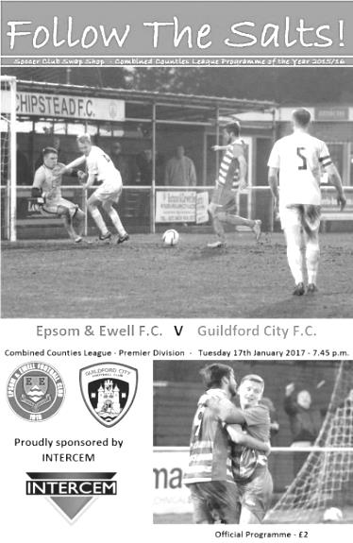
Hastings header turns the tables against Guildford

Did you know that every time Craig Hastings scores for the Salts, not only do we win the match but we keep a clean sheet too! I will concede that statistic is a little tenuous as it is only Craig's second goal for the club, but there were a lot of similarities between this match and the Bridon Ropes Vase tie in which he scored his other goal, as we took a deserved first half lead and in the second kept our opponents at arms length, rarely looking like conceding despite the absence of our suspended Captain Dan Dean.

On a chilly night at Chipstead my car told me that the temperature was minus 2 degrees and that was an hour before kick off. Despite the cold, 37 hardy souls trekked up to High Road with the hope that we could reverse the result against our opponents from seven days previously, and they were rewarded with an entertaining match between two hard working and committed sides. In fairness nobody out there was going to stay still for long!

We made three changes from Saturday's defeat at Hanworth Villa. In addition to the suspended Dean, Daryl Cooper-Smith was unavailable and Adam Heagney switched to the bench with Reisse Griffin having a run at right back. Jason Nwachukwu came in up front, just behind Rob Hendry, while Savvas 'Agi' Panayiotou slotted in to the midfield holding role where he battled all evening, winning many important tackles.

We had a good opportunity as early as the second minute when Hendry was fouled on the edge of the area but Matt Ferdinando's free kick was high and wide. In fact hitting the target would prove to be the main issue today as Jordan Gallagher curled a shot just over from 12 yards, although admittedly it wouldn't have counted as he had strayed offside.

In the 13th minute we had a free kick and it was a good sign that Hastings was able to win the header, although wasn't on this occasion able to do more than head the ball wide of Luke Badiali's right hand post. Ferdinando was next to try his luck after good work from Nwachukwu, but his shot was deflected wide off a defender with the resultant corner causing no danger.

The visitors had been restricted to two attempts by this stage, one of which was a long range effort that was well over the bar and another that was met by a glancing header but with minimal contact and the ball went well wide. Gallagher then sent a Ferdinando pass over the bar and it was beginning to look a little like Saturday's match at Hanworth Villa where we had much of the ball but did little of quality with it.

In the 39th minute Darryl Siaw either stumbled or was tripped and fell on the ball. Expecting the free kick he stuck out an arm to retrieve the ball but no foul had been given and he was booked for deliberate handball. From the free kick a minute later we extracted the full penalty as Ferdinando sent over a peach of a free kick and Hastings had achieved a bit more separation towards the far post, enabling him to send a textbook header across the helpless Badiali into the opposite corner.

The visitors responded with a 25 yard free kick that had been clumsily given away, but the delivery went straight into the hands of Michael Eacott who finally had a shot on target to save in the 42nd minute. This was the score at the half; a deserved, but precarious lead.

We could and maybe should have had a penalty within 25 seconds of the second half when Gallagher was bundled over from behind, but the referee wasn't impressed and the visitors broke away. Fortunately we were able to snuff out any danger, looking particularly compact around the edge of our own area. Both teams were still committed to attack and next to try his luck was Matt Tanton who won the ball off a defender and let fly from 20 yards but he dragged his shot just beyond the far post, while the visitors also had a long range attempt from 30 yards that Eacott watched as it sailed high and wide.

Ferdinando was next to be involved when he made a mazy run on the right but slipped and landed awkwardly, hurting his arm or shoulder. There were two concerns here as not only was our man injured, but whether the slip on the increasingly freezing surface would give the referee any thoughts of an abandonment, but that was probably because we were winning. In truth the pitch played well all match and this was pretty much the only fall. However Ferdinando soon made way for Adam Heagney, with the young right back assuming his position on the field, with Griffin maybe surprisingly remaining at right back.

In fairness Heagney did well in his advanced role and was unfortunate not to score on a couple of occasions. He had a shot charged down by a defender with the ball dribbling through to the keeper just before our man could reach it, and in the 66th minute Gallagher fed him from the left but his snap shot was straight at Badiali who parried the ball to safety.

We picked up another free kick for handball, this time from their Captain Matt Males, who was extremely unfortunate to receive a booking for it. Hendry's free kick squirmed through the wall and the loose ball was drilled at goal but was deflected away. The second half contained more of a contribution from the visitors though as they began to push us back more. Their main opportunity came with quarter of an hour remaining when they had a free kick out on the touchline. The free header at the near post really ought to have been on target but went wide.

With five minutes remaining a flat kick from Eacott went straight through the middle of the Guildford defence and Hendry was on it and through on goal, but a really heavy touch gave the relieved Badiali the chance to claim the ball. It was nearly an assist for Eacott, but he and the team will be more than happy with the clean sheet. In summary we probably should have put this game to bed earlier but the three points were very welcome and we remain unbeaten at home in the League since August.

Epsom and Ewell: Michael Eacott, Reisse Griffin, Matt Tanton, James Taylor, Craig Hastings, Savvas 'Agi' Panayiotou, Jordan Gallagher, Matt Farrell (c), Jason Nwachukwu, Rob Hendry,
Matt Ferdinando

Subs: Adam Heagney for Ferdinando (58), Alex McKay for Nwachukwu (82)

Badshot Lea F.C. – History
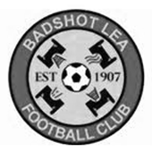
Early history suggests that the village football club was formed in 1904, after a meeting at the local village hall. They initially played friendly matches before deciding that they affiliate to the Surrey County Football Association in 1907.

They began life in the junior leagues before gradually progressing through the leagues. The most recent history shows the Lea playing in the Aldershot leagues and progressing through the various divisions, eventually obtaining promotion to the Surrey Intermediate League Western in 1978.

Progress through the three divisions saw the Lea eventually promoted to the Surrey Premier League in 1986. This was for one year only as we obtained the dubious distinction of being relegated with the highest points total ever achieved by a side being relegated.

Season 1988 saw us again in the Surrey Intermediate League Western. The ensuing years saw the ups and downs that one experiences until season 2002/03 which saw eventual promotion to Senior Football via The Hellenic League. This was not without its problems as The FA at Soho Square tried to block the move. It was only the determination of the committee and the full backing of The Hellenic League that eventually saw us given the green light.

In our first season we took time to adjust to Senior Football eventually finishing 4th from bottom under the guidance of manager Maurice Gregory. Season 2004/05, David Ford took over the management reigns with Nathan Fealey and in their first season took the side to a credible 7th place finish. Season 2005/06 saw the 1st team finish mid table and reach two cup finals. They narrowly lost out to Sandhurst Town in the Aldershot Senior Cup on penalties but beat Penn & Tylers Green in the Hellenic Supplementary Cup.
2006/07 saw them yet again lose out on penalties in the Aldershot Senior Cup this time against Camberley Town. On the league front they produced some fantastic football all season and after chasing Bisley Sports for most of the season ended up finishing in 3rd place. It was enough to enable up to take up a promotion position and with a groundshare secured with near neighbours Farnborough we were able to do so.

2007/08 season under the guidance of Dave Ford we finished our first season at Step 5 in a respectable 11th place and beaten finalists in the Aldershot Senior Cup losing by the odd goal against Fleet Town. The National League’s Committee then sanctioned a move to the Combined Counties Premier League for season 2008/09 where we swapped places with Reading Town.

Season 2009/10 saw us reach the 2nd qualifying round of the F.A. Cup as well as reaching the 3rd round proper of the F.A. Vase. We also reached the Semi Final of the Surrey Senior Cup beating Woking on the way.

Season 2010/11 saw us finish 6th in the league and finally win the Aldershot Senior Cup defeating Fleet Town on penalties. Season 2011/12 saw us finish in a disappointing league position, the lowest at Step 5. We still managed to get to a Cup Final at Aldershot Town, where we lost out to Ashford Town (Middx) in The Aldershot Senior Cup Final.

Season 2012/13 saw Mark Anderson replace Dave Ford as manager and he finished in an excellent 7th place and also led the team to the FA Cup 3rd Qualifying round where after beating Ryman League sides Folkestone Invicta and Premier side Leiston, finally lost out to Southern Premier side Chippenham Town.

Mark Anderson resigned for personal reasons in July 2013 and the club appointed Ryan Scott and Nick Sowden as joint managers. In November 2013 Trevor Norris was appointed and he steered us to a safe position at the end of the 2013/14 season. In September 2014 Trevor Norris resigned his position as manager and was replaced by Mark Thomas. He was joined by James Reeves and Coach Darren Barnard.

The 2013/14 season was a strange one. A slow start was replaced by a run of blistering form as the club raced up the table, only to fall away a little towards the end and a satisfactory 8th place was the final position although the two seasons that followed contained less of note. Now with a new ground closer to reality the future is bright.

First Eleven Appearances 2016/17 - (max 38)
Name | Debut | 2016/17 |  |  |  | Career Totals
 |  | App | Sub | Total | Goals | App | Sub | Total | Goals
CLARK-GLEAVE Charlie | 23/08/2016 | 3 | 2 | 5 | 0 | 3 | 2 | 5 | 0
COOPER-SMITH Daryl | 03/01/2015 | 25 | 4 | 29 | 25 | 55 | 12 | 67 | 45
DEAN Dan | 02/08/2014 | 27 | 2 | 29 | 0 | 95 | 6 | 101 | 2
DEWAR Ali | 29/10/2011 | 0 | 1 | 1 | 0 | 55 | 36 | 91 | 10
EACOTT Michael | 02/08/2014 | 30 | 0 | 30 | 0 | 115 | 1 | 116 | 0
FARRELL Matt | 02/08/2014 | 34 | 0 | 34 | 14 | 120 | 4 | 124 | 32
FERDINANDO Matt | 20/09/2014 | 20 | 7 | 27 | 5 | 73 | 13 | 86 | 19
GALLAGHER Jordan | 07/08/2016 | 24 | 12 | 36 | 10 | 24 | 12 | 36 | 10
GRIFFIN Reisse | 08/08/2015 | 28 | 6 | 34 | 2 | 56 | 12 | 68 | 4
HASTINGS Craig | 08/08/2015 | 25 | 7 | 32 | 2 | 62 | 11 | 73 | 2
HEAGNEY Adam | 16/08/2016 | 24 | 6 | 30 | 0 | 24 | 6 | 30 | 0
HENDRY Rob | 08/08/2015 | 28 | 7 | 35 | 7 | 58 | 18 | 76 | 19
MCKAY Alex | 20/12/2008 | 18 | 4 | 22 | 3 | 126 | 34 | 160 | 11
NEALE Tom* | 13/10/2015 | 6 | 5 | 11 | 7 | 22 | 24 | 46 | 17
NORTH Rhys* | 16/08/2015 | 2 | 2 | 4 | 0 | 19 | 9 | 28 | 1
NWACHUKWU Jason | 01/10/2016 | 8 | 10 | 18 | 0 | 8 | 10 | 18 | 0
PANAYIOTOU Savvas | 03/01/2015 | 30 | 4 | 34 | 4 | 62 | 12 | 74 | 11
PRICE Matt* | 23/08/2016 | 2 | 0 | 2 | 1 | 2 | 0 | 2 | 1
ROBINSON Sam* | 22/10/2011 | 7 | 1 | 8 | 1 | 61 | 6 | 67 | 14
ROSE Daniel | 25/10/2016 | 2 | 5 | 7 | 0 | 2 | 5 | 7 | 0
SALEH Mennar* | 24/09/2016 | 0 | 2 | 2 | 0 | 0 | 2 | 2 | 0
SMITH Matt | 08/08/2009 | 0 | 2 | 2 | 1 | 91 | 45 | 136 | 11
TANTON Matt | 02/08/2014 | 32 | 1 | 33 | 1 | 89 | 5 | 94 | 3
TAYLOR James | 26/08/2013 | 31 | 3 | 34 | 2 | 117 | 15 | 132 | 8
THOMPSON Elliott | 09/02/2016 | 3 | 0 | 3 | 1 | 7 | 9 | 16 | 1
TURPIE Alistair | 31/03/2016 | 8 | 1 | 9 | 0 | 10 | 1 | 11 | 0
WATRET Jack* | 02/08/2016 | 1 | 0 | 1 | 0 | 1 | 0 | 1 | 0
* player has left the club

Club Records - 4th February
Date | Day | Competition |  | Opponents |  | Scorers
04/02/28 | Sat | Friendly | A | Sutton United | 1-1 | R.Marlow
04/02/33 | Sat | Friendly | H | Uxbridge | 3-1 | L.Graves (2), J.Gillespie
04/02/39 | Sat | London League | A | P.O.Engineers | 2-1 | G.Collins, B.Solly
04/02/50 | Sat | Corinthian League | A | Eastbourne | 1-5 | T.Wright
04/02/56 | Sat | Corinthian League | A | Grays Athletic | 5-1 | B.Jenkins (2), D.Hermitage (2), T.Day
04/02/61 | Sat | Corinthian League | A | Edgware Town | 1-5 | B.Hawkins
04/02/67 | Sat | Athenian League 2 | H | Edmonton | 2-1 | T.Stafford, T.Williams
04/02/78 | Sat | Isthmian League 2 | H | Tring Town | 0-3
04/02/86 | Tue | Isthmian League Cup QF | H | Uxbridge | 1-1+ | o.g.
04/02/89 | Sat | Isthmian League 2s | A | Feltham | 1-1 | L.Harding
04/02/92 | Tue | Associate Members Trophy 3 | H | Cove | 0-1
04/02/95 | Sat | Isthmian League 3 | A | Southall | 1-2 | S.Smith
04/02/97 | Tue | Isthmian League 3 | H | Flackwell Heath | 5-0 | A.Boxall (2), T.Boorman, G.Meakin, o.g.
04/02/99 | Thur | Associate Members Trophy 3 | A | Banstead Athletic | 4-1+ | A.Rawlinson, S.Grant, K.Webb, o.g.
04/02/03 | Tue | Isthmian League 1s | A | Molesey | 1-0 | K.Webb
04/02/14 | Tue | Combined Counties  Premier Division | H | Hartley Wintney | 4-2 | A.McGregor, M.Jarman (2), K.Douglin
Historical Decades
90 years ago – Epsom Town F.C.
05/02/27 | Sat | Surrey Senior League  Charity Cup 2 | H | Reigate Priory | 7-2 | R.Marlow (3), F.Behn (3), T.Birch
80 years ago – Epsom F.C.
06/02/37 | Sat | London League | A | Dagenham Town | 2-2 | F.Pidgeon (2)
70 years ago – Epsom F.C.
08/02/47 | Sat | London League | A | Crittall Athletic | 1-0 | R.Bostock
60 years ago – Epsom F.C.
02/02/57 | Sat | Corinthian Memorial  Shield 2 Replay | A | Slough Town | 5-2 | J.Bangs (3), D.Hermitage, o.g.
50 years ago – Epsom & Ewell F.C.
04/02/67 | Sat | Athenian League 2 | H | Edmonton | 2-1 | T.Stafford, T.Williams
40 years ago – Epsom & Ewell F.C.
05/02/77 | Sat | Athenian League Cup 2 | A | Hounslow | 2-0 | T.Tuite, M.Peters
30 years ago – Epsom & Ewell F.C.
03/02/87 | Tue | Isthmian League 1 | A | Lewes | 0-2
20 years ago – Epsom & Ewell F.C.
04/02/97 | Tue | Isthmian League 3 | H | Flackwell Heath | 5-0 | A.Boxall (2), T.Boorman, G.Meakin, o.g.
10 years ago – Epsom & Ewell F.C.
03/02/07 | Sat | Combined Counties  Premier Division | H | Bookham | 1-1 | A.Myers

History Corner - 4th February
90 years ago this week we hosted Reigate Priory in the Surrey Senior League Charity Cup. This was the League Cup back then. We had recently lost to Woking in the Surrey Senior Cup but that aside were in superb form on our way to winning the League for the second time in a row. This year we would add the Cup for a memorable double and after we had received a bye in the first round Priory were simply brushed aside in this second round tie, probably wishing they hadn’t bothered defeating Dorking in a replay in the previous round! Reg Marlow scored his fourth hat trick in four straight matches and Freddie Behn joined in with three of his own. Terry Birch got the other goal in this 7-2 win and it would get worse the following week as they returned to West Street for a League match, losing 7-0 and with Marlow going on to make history with a fifth hat trick!

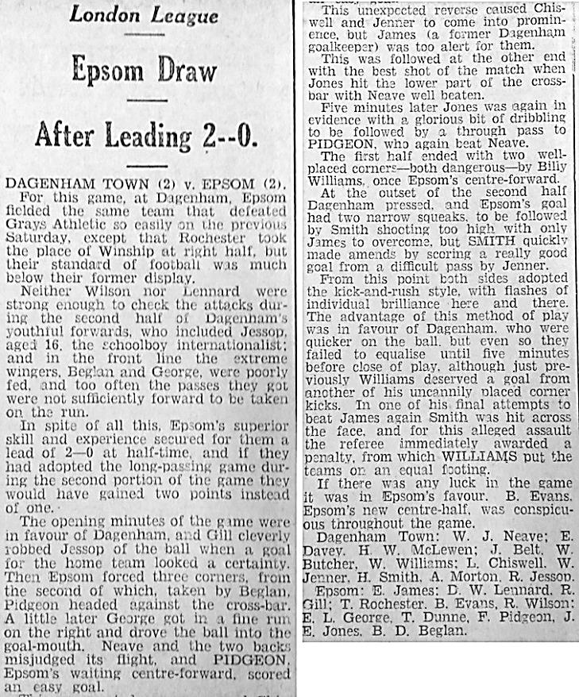
80 years ago this week we visited Glebe Road in Dagenham which was the home back then of Dagenham Town, a London League team. Although no connection to the current Dagenham & Redbridge who were originally founded as Dagenham F.C. in 1949, this was the main club in the town back then and they regularly drew gates of over 3,000 for matches with us, so who knows how many they would have had for local derbies! This week we led 2-0 at the half with a couple of goals from F.Pidgeon but had to return home with just the one point from a 2-2 draw.

60 years ago this week Johnny Bangs our new striker was having a great season and scored three more as Slough Town were smashed 5-2 in this Corinthian League Memorial Shield Second Round replay in front of their own fans at the long since built over Dolphin Ground. Johnny Bangs would go on to score 53 goals this season, not the 55 that was claimed by the local papers as a new post war club record, as recent checks have confirmed that there was an error in the counting! Still 53 goals in 39 matches is still pretty good and a higher mark than Tommy Tuite ever reached in a season. We would go on to reach the Final of the competition, losing at Meadowbank to Maidenhead United.

14 years ago today Kevin Webb scored the only goal at Molesey but this was soon forgotten as he was involved in a serious car accident straight after the match when a drunk driver collided with him. He had to be cut out of the vehicle but was able to play in our next match four days later.

My Club Betting
We can now announce that Epsom & Ewell F.C.
now have our own betting site!

If you like to have a bet, this is most definitely for you.

In conjunction with MyClubBetting.com you can now access all the regular markets that you might do regularly with just a click on our website.

But why would you do this? Many of you already might have apps that you currently use.

The main reason is that you would benefit the club by doing so, but at the same time would not lose out yourselves. Their odds are at least comparable and in many cases better than the other bookmakers out there and by registering with us, the club would make 20% of any cumulative losses and with enough usage, we would qualify for other fairly substantial club benefits.

If you win the bet that you place, that is fantastic news, but whichever company you use currently would keep 100% of any losses. This way our club can receive a nice lump sum in the event that you are unlucky.

For example. If we have 20 people signed up and they lost £25 over the month each, our club would receive £100 back out of the £500 lost.

So just visit: https://eefc.myclubbetting.co.uk/ and join the club!

Combined Counties League Premier Division
Opponents All-time Records
incl Tuesday 31st  January | P | W | D | L | F | A | PPG | GD | Best  Win | Worst  Loss
Bedfont & Feltham | 1 | 1 | 0 | 0 | 9 | 2 | 3.00 | +7 | 9-2 | X
Spelthorne Sports* | 6 | 5 | 1 | 0 | 15 | 6 | 2.67 | +10 | 6-2 | X
Sutton Common Rovers | 12 | 9 | 2 | 1 | 30 | 14 | 2.42 | +16 | 4-0 | 1-4
Horley Town | 29 | 20 | 5 | 4 | 65 | 30 | 2.24 | +35 | 6-0 | 1-3
Colliers Wood United | 22 | 14 | 2 | 6 | 45 | 33 | 2.00 | +12 | 4-0 | 0-5
Bedfont Sports | 10 | 6 | 2 | 2 | 18 | 11 | 2.00 | +7 | 5-1 | 0-4
Abbey Rangers | 3 | 2 | 0 | 1 | 10 | 4 | 2.00 | +6 | 7-1 | 2-3
Guildford City | 18 | 11 | 1 | 6 | 35 | 22 | 1.89 | +13 | 5-1 | 1-5
Westfield | 19 | 11 | 3 | 5 | 40 | 31 | 1.89 | +9 | 6-1 | 0-4
Farnham Town | 14 | 8 | 2 | 4 | 25 | 23 | 1.86 | +2 | 3-1 | 1-4
Knaphill | 7 | 4 | 1 | 2 | 15 | 8 | 1.86 | +7 | 4-0 | 1-2
Walton & Hersham | 51 | 25 | 10 | 16 | 104 | 98 | 1.67 | +6 | 6-0 | 0-8
Badshot Lea | 18 | 8 | 3 | 7 | 35 | 34 | 1.67 | +1 | 4-1 | 0-4
Hanworth Villa | 17 | 8 | 4 | 5 | 38 | 27 | 1.65 | +11 | 5-0 | 1-4
Raynes Park Vale | 28 | 13 | 7 | 8 | 59 | 38 | 1.64 | +21 | 6-1 | 0-2
Camberley Town* | 89 | 38 | 22 | 28 | 158 | 123 | 1.52 | +35 | 9-1 | 0-4
Hartley Wintney | 11 | 4 | 3 | 4 | 26 | 20 | 1.36 | +6 | 5-0 | 2-4
Windsor | 49 | 19 | 12 | 18 | 90 | 90 | 1.41 | 0 | 4-0 | 0-6
Chertsey Town | 48 | 18 | 5 | 25 | 72 | 87 | 1.23 | -15 | 3-0 | 0-7
North Greenford United | 11 | 3 | 2 | 6 | 15 | 20 | 1.00 | -5 | 3-0 | 1-4
AFC Hayes | 10 | 2 | 3 | 5 | 18 | 18 | 0.90 | +1 | 7-0 | 0-3
CB Hounslow United | 2 | 0 | 0 | 2 | 2 | 7 | 0.00 | -5 | X | 1-5
* includes one abandoned match v Camberley and one loss on penalties v Spelthorne

Centre page for results

Centre page for results

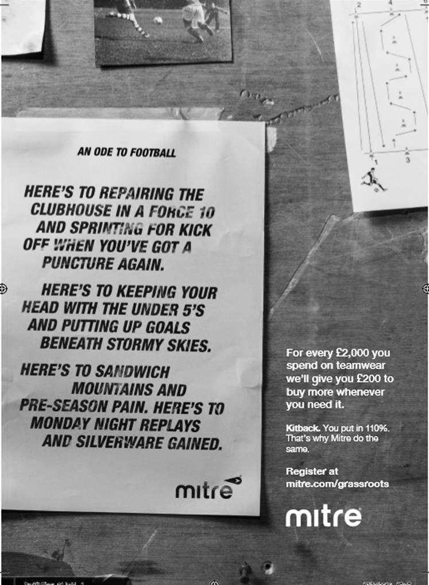

Surrey Senior Cup
Third Round
Whyteleafe | 2-0 | Egham Town
Badshot Lea | 0-2 | Raynes Park Vale
Epsom & Ewell | 1-2 | Guildford City
Dorking Wanderers | V | Sutton Common Rovers
Chertsey Town | 1-0 | Kingstonian
Woking | 2-0 | Leatherhead
Merstham | 5-1 | Walton & Hersham
Tooting & Mitcham United | 0-1 | Knaphill
Quarter Final
Guildford City | V | Raynes Park Vale
Chertsey Town | V | Dorking Wanderers / SCR
Merstham | V | Whyteleafe
Woking | V | Knaphill

F.A. Vase
Fifth Round – 28th / 29th January
Cleethorpes Town | 3-2 | Atherton Collieries
Southall | 4-2 | Exmouth Town
Bromsgrove Sporting | 2-1 | Bristol Manor Farm
Crowborough Athletic | 3-6 | Coleshill Town
Hinckley AFC | 3-4+ | Buckland Athletic
Newport Pagnell Town | 3-2+ | Sunderland RCA
Ely City | 0-3 | Sporting Khalsa
Team Solent | 2-5 | South Shields
Quarter - Final – 18th February
South Shields | V | Newport Pagnell Town
Southall | V | Cleethorpes Town
Bromsgrove Sporting | V | Buckland Athletic
Coleshill Town | V | Sporting Khalsa

EL Records Premier Challenge Cup
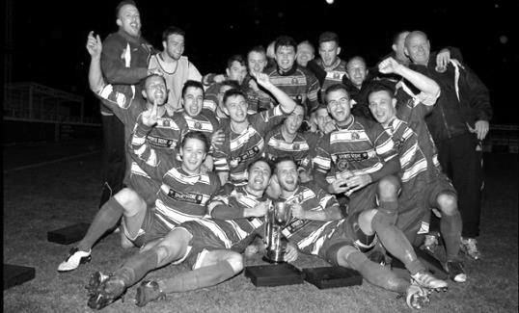
Second Round
Hanworth Villa | 2-4+ | Epsom and Ewell
AFC Hayes | 3-4 | Balham
Epsom Athletic | 1-5 | Windsor
Sutton Common Rovers | 2-1 | Bedfont Sports
Raynes Park Vale | 2-0 | Colliers Wood United
Frimley Green | 1-2 | Banstead Athletic
Westfield | 8-4+ | Redhill
Staines Lammas | 0-1 | Farnham Town
Worcester Park | 8-1 | Cove
Badshot Lea | 0-5 | Guildford City
Chertsey Town | 1-2 | Camberley Town
Cobham | 1-3 | Chessington & Hook United
Hartley Wintney | 4-0 | AC London
Horley Town | 2-2+ 5-4p | Sheerwater
Walton & Hersham | 5-1 | Eversley & California
Ash United | 2-0 | Farleigh Rovers
Third Round
Banstead Athletic | 4-4+ 3-4p | Westfield
Sutton Common Rovers | 1-3 | Walton & Hersham
Farnham Town | 0-4 | Camberley Town
Ash United | 0-2 | Windsor
Raynes Park Vale | 2-1 | Hartley Wintney
Guildford City | 2-1 | Balham
Horley Town | 2-0 | Chessington & Hook United
Worcester Park | 3-6 | Epsom & Ewell
Quarter Finals
Windsor | 2-0 | Horley Town
Guildford City | 22/2 | Raynes Park Vale
Westfield | 14/2 | Camberley Town
Walton & Hersham | 1-3 | Epsom & Ewell

From behind the goal
A.F.C. Hayes 1-0 Epsom & Ewell
Combined Counties League - Premier Division - Saturday 28th January 2017

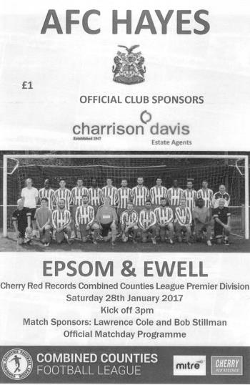
Toothless Epsom pay the price

The stark facts of Saturday's encounter are that an 88th minute penalty, awarded for a tug on a player by midfielder Agi Panayiotou ensured defeat for the Salts. However, and leaving aside for the moment that the tug appeared minimal and the attacker went down like a ton of bricks, this was the first goal we had conceded in over four hours of football. The real problem lies up front right now.

In the last three matches we have scored one goal and that came from central defender Craig Hastings. It is for this reason alone that we have to come to terms with our second defeat in three matches; this time against a very average AFC Hayes outfit that spent much of the game camped in their own half and which only produced one other shot on target during the 90 minutes. Make no mistake, this was a winnable match and the players knew it. "No end product" said Glyn to the players after the game and this was exactly what was being said by everyone else around the ground during it.

We made three changes for this match after our win over Guildford City. Dan Dean returned from suspension to make his 100th appearance for the club so Hastings moved to the bench, while Adam Heagney came back in at right back so Reisse Griffin was restored to his more regular berth on the right wing, leaving Matt Ferdinando also amongst the substitutes. Finally, Alex McKay came in for the suspended Matt Farrell and for the first time since our midfield dynamo has been at the club it could be argued that we didn't miss his midfield presence as McKay and Panayiotou both had excellent games in the middle of the park.

However, neither player gets forward as frequently as Farrell does and we could have really done with this as our front players were unable to register a challenging shot on target until the 87th minute. Admittedly the pitch was extremely heavy but after two weeks of frost it was always going to be this way.

We dominated right from the start as wave after wave of yellow attack came up the hill at the AFC Hayes defenders. One of the most interesting factors of the match was the battle between Griffin and the home team's impressive youngster Harry Bishop who was excellent against us in the earlier draw back in November and surely will be playing at a higher level soon. These two went at it toe to toe with neither giving an inch. On the left flank Jordan Gallagher also tried to get around the other full back Kildane Tesfu but on the occasions that we did get past them, the quality of service let them down, while both Rob Hendry and Jason Nwachukwu failed to create enough space either.

A Gallagher free kick which trundled through to the keeper Cameron Kennedy from 25 yards occurred in the fourth minute and just after this Gallagher's best cross of the day was met at the far post by Griffin and Bishop and resulted in a head injury to the latter. We then had the rare sight of a contested drop ball which was won by McKay who fed Matt Tanton, but his shot was a

couple of yards wide of the goal. This was followed by shots from Gallagher and Heagney but neither were on target and after about 25 minutes the home side started to venture up the other end and created a few opportunities of their own. The previously untroubled Michael Eacott had to pluck a far post volley out of the sky that almost went over him but he made a superb low save in the 32nd minute after Sekani McCalmon had found space on the edge of the area and fired the ball low towards the corner, taking a slight deflection on the way.

They nearly cut us apart with a move from the left but Dean was there to make a timely interception and as we went off at the half I felt that we had missed the boat. However, we started well in the second half too with McKay volleying at goal in the opening thirty seconds. This was followed by a dangerous run by Nwachukwu who found his shot blocked for a corner from which we nearly opened our account. The first delivery was returned back out but the second was met by Dean at the far post whose goal bound shot was cleared off the line by a defender.

Gallagher was next to threaten but tried to trick his way around too many defenders and Kennedy smothered the threat close to goal with Hendry waiting in the middle for the delivery. We made a couple of subs with Ferdinando and Hastings coming on for Gallagher and McKay respectively and it was unusual to see Hastings operating in a defensive midfield role, a position he grew into. We continued to do most of the pressing and Hendry was set up by Nwachukwu but curled his shot away from the far post before a Hendry free kick from 30 yards was not held cleanly by Kennedy and Griffin reached the loose ball first only to be flagged offside; a contentious decision.

Ferdinando jumped well for a right wing cross from Dean who had found himself out on the right, but couldn't direct his header on target and this was the case when he pulled the ball wide from a snapshot on the edge of the area. A good Hendry corner was met by a header on target by James Taylor but this was blocked away by a defender and Hastings headed a deep free kick narrowly wide soon after. It was beginning to look like the only way we would score was from a set piece and with just three minutes remaining another one led to a big scramble in the six yard box with Nwachukwu's close range shot blocked across goal by Kennedy where a defender just got a toe to the ball ahead of the incoming Taylor; the ball squirming inches wide of the post for a corner.

For all this work we certainly didn't deserve what came next as a ball across our back four found McCalmon one on one with Panayiotou. It looked at first as though our man had dealt with it but then the home player hit the deck and a penalty was given and was calmly hit down the middle by Reece Charles-Jones in the 88th minute. From where I stand it looked very soft but there was little in the way of an appeal from our players and bearing this in mind our man was probably fortunate to avoid a yellow card, or even a red one as a pull on a player inside the box is still seen as preventing a goal scoring opportunity.

Despite further pressure we were unable to break through and had to accept defeat. You could call it daylight robbery and I could also go on about the fact that the opposition kicked the ball away four times between the 88th minute and the 95th when the game finished; an offence which continually seems to result in a yellow card when our players do it, yet right at the end Tanton was booked for saying something when a throw went against him. This was equally frustrating as their Manager had a full blown hissy fit just before half time, yet a lecture was all he received. Officiating consistency hurts us once again, but we cannot escape the facts. We didn't score again and will continue to pay the price until that changes.

Epsom and Ewell: Michael Eacott, Adam Heagney, Matt Tanton, James Taylor,
Dan Dean ©, Alex McKay, Jordan Gallagher, Savvas 'Agi' Panayiotou,
Jason Nwachukwu, Rob Hendry, Reisse Griffin
Subs: Matt Ferdinando for Gallagher (66), Craig Hastings for McKay (66)

From behind the goal
Walton & Hersham 1-3 Epsom & Ewell
Combined Counties League Cup - Quarter Final - Tuesday 31st January 2017

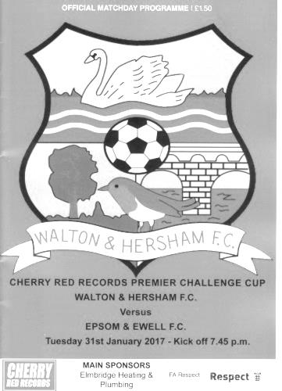
Hard earned win puts Salts in the Semi Final

On a very wet evening at Stompond Lane we overcame the setback of conceding an early goal to outwork and eventually outlast our local opponents by a scoreline of 3-1 which could have been heavier on another day and at the same time enable the long term supporters to lay to rest memories of two fairly recent crushing defeats against them (2003/04 - 0-8 & 2009/10 - 4-5 aet).

Already aware that we would be missing the suspended Matt Farrell, the team sheet showed that Matt Tanton was also unavailable, so Reisse Griffin moved over to left back and Craig Hastings came into the starting eleven with James Taylor at right back in place of Adam Heagney who was on the bench.

Filling the hole left by Griffin up front was Jason Nwachukwu who moved to the right wing to accommodate Matt Ferdinando who continued his recent appearances in a central role behind Rob Hendry. We were also boosted by the appearance on the bench of Daryl Cooper-Smith, Ali Dewar and Ali Turpie, none of whom had been available for a few weeks.

There were many postponements elsewhere but the Stompond Lane pitch looked good enough and played well throughout the match which was played in a constant downpour but with no animosity whatsoever. It was a day for hassling your opponent into making mistakes but the first error came at our end in the 7th minute. Dan Dean was penalised for a foul on the edge of the area, but out at a wide angle and as the low delivery came in Alex McKay was first to the ball to smash it clear. Unfortunately his contact was not as desired and the ball sliced off the edge of his boot and into the far corner of the net, giving Michael Eacott no chance whatsoever. Only now, looking back and safe in the knowledge of the result can we look back and say that it was actually quite a comical own goal!

But at the time it was a hammer blow. Well aware of the small number of goals we had scored recently, we faced an uphill climb against a team that had conceded less goals than any other in our division this season. It was difficult for a while with a couple of players becoming frustrated with an eccentric refereeing performance that started with lectures for a couple of players for very little and then finished with a yellow card for Craig Hastings on the quarter hour for querying why the referee had not spotted a foul on him in the Walton penalty area. I feared that we were going to get a stop - start match ruined by constant whistling, but fortunately we were able to rise above it.

That penalty claim wasn't awarded but we did have a corner and from it, Jordan Gallagher sent a header towards goal which was blocked and then cleared by a defender; the ball dropping onto the roof of his own net. We followed this up with a couple of half chances but neither were too threatening; Ferdinando's free kick sailing high over the ball and McKay's 25 yarder being easily gathered by Liam Beach. Agi Panayiotou then did well to create a chance for Gallagher who cut in and drilled the ball just over the bar from 20 yards. I remarked to those around me at the time that Jordan was going to score one of those soon.

Epsom pressure continued but on the counter attack the Swans glided upfield and fired at goal, the ball rebounding back into play off of Eacott's left hand post and the danger was cleared. Eacott got the faintest of touches to the ball and it could be argued that this was the moment where the game turned

in our favour, as within a minute we were level. With the clock in the 30th minute Hendry got down the right wing and sent in a beauty. At full stretch Ferdinando managed to reach the ball and this completely wrong footed Beach who was clearly expecting it to skip through and had already started to move across his goal. Ferdinando then had the easy task of smashing the ball into the net from a yard or two out to put us on even terms. We nearly scored again two minutes later when a free kick in was dropped by Beach at Taylor's feet but he was only able to scuff the ball onto a post from close range and the ball fell kindly for Beach to gather.

For all our pressure we still had concerns, although as the game went on these became fewer. One came in the 35th minute when Dan Dean and Eacott were a bit indecisive about whether the long ball was going to travel through into our keeper's area before the attacker reached it. Dean was in Eacott's way for a bit and big Mike then sliced his kick across goal but Dean was there to block an incoming shot from just inside the box and we were able to breathe again. Then Eacott had to punch away a dangerous free kick delivered from the same area that their goal came from, but we were soon back on the attack and Panayiotou won the ball in his own half and set up Hendry for a run and shot that was deflected wide of goal from the edge of the area.

The home side didn't heed the warning though and in first half injury time Ferdinando won a header just outside his own penalty area. He then was first to the loose ball and broke away, feeding Gallagher down the left, where our left winger cut inside and this time drilled the ball low into the bottom corner from just outside the area. With the whistle coming seconds later, it was a great time to take the lead.

And 2-1 became 3-1 in the 48th minute. A Walton defender was trying to see the ball out for a goal kick but was robbed by a combination of Ferdinando and Hendry, with the latter running in at goal, drawing the defender and laying the ball back for Ferdinando to score from close range. I expected that Walton would really come at us from this point, but we held firm and continued to make the better chances. Nwachukwu took advantage of a defensive error and then used his pace to get a toe to the ball and put himself through on goal, but curled the ball around Beach and just the wrong side of the post too.

With supporters well aware of the last time we had played Walton and Hersham in a Cup competition, when we let a 4-1 lead slip to lose in extra time, we were concerned up in the stand that we hadn't taken full advantage of our chances and whether it would come back to haunt us as it had on Saturday, and when Gallagher and Griffin got in each other's way the ball was fed to the opposite side of the goal where a home attacker was in space but he dragged his shot wide. We then charged another shot down so that it had no pace on it by the time it got through to Eacott. It looked like it would be our night.

In the 71st minute we had a contentious incident when Hendry got a toe to the ball ahead of a defender's challenge that left him on the floor. He would have been through on goal and yet no free kick or accompanying card was issued and they broke away and with numbers over, had a man at the far post who fortunately for us scuffed his volley across goal. Had it gone in directly it could have been a really bad moment but the ball was instead tapped in at the far post by a player who was flagged offside. A lucky break which could have been avoided if the right decision had been made earlier on in the move.

We had further chances to put the tie to bed and in the 78th minute Gallagher put Ferdinando through with a nice reverse pass but maybe he was thinking of his hat trick and he sliced his chance horribly wide with only Beach to beat. Cooper-Smith entered the fray and in the 90th minute held the ball up before putting Gallagher through. As he went towards goal he was brought down for the penalty but Ferdinando then skied the spot kick on a wet day when low and hard was surely the only way to take it. Fortunately it didn't matter and we await the Semi Final draw with great interest.

As was the case on Saturday at AFC Hayes we conceded just the once, but we proved in this match that it really isn't too serious if you are scoring plenty at the other end!

Epsom and Ewell: Michael Eacott, James Taylor, Reisse Griffin, Craig Hastings, Dan Dean ©, Savvas 'Agi' Panayiotou, Jordan Gallagher, Alex McKay, Rob Hendry, Matt Ferdinando,
Jason Nwachukwu

Subs: Daryl Cooper-Smith for Hendry (80) Adam Heagney for Ferdinando (92)

Every Opponent A-Z
Over the years we have played many, many different opponents. Exactly how many is a difficult question, as it all depends on your definition. Are Camberley & Yorktown different to Camberley Town, or are Epsom Town different to Epsom F.C. or Epsom & Ewell F.C.?

In my analysis I have classed both of the above examples as the same team, and will work through them all from A to Z. Some we have played many times, whilst others we have met just once or twice. Enjoy!

Uxbridge: Played 62 - W19 D5 L38 - F97 A152 - PPG - 1.00 - Poor

Uxbridge are one of the oldest clubs in the country, being formed way back in 1871 and even reaching the Amateur Cup Final in 1898. As we have not met since 1987, it may be be surprising to many to learn that we have contested so many matches, sitting fifth on our list of all time opponents and they are only behind Tilbury in the list of non-Surrey opponents.

We met for the first time in a friendly at West Street on 4th February 1933 and winning 3-1 back in the days that friendlies were considered as competitive fixtures (until 1960). We then met just before World War Two when they joined the London League, playing at the R.A.F. Stadium in Northolt, which existed until recently, just off Honeycroft Hill, although a Territorial Army base still remains there. We won 5-2 on our only visit, completing a league double in March of 1939 with a 3-0 win back at West Street.

They remained in the London League when it reformed after the war, as did our club, although Uxbridge appear to have had ground difficulties that season as both matches were played at West Street. It didn’t stop them winning there by an incredible score of 9-3 in October of 1945, although we redressed the balance somewhat with a 4-3 decision in our favour in the following February.

Regular meetings commenced when we moved to the Corinthian League in 1949 where the bulk of our matches took place and we remained as League opponents without a break until 1965. We started with a pair of losses in 1949/50, the latter of which was a heavy 6-2 defeat at their old Honeycroft ground, which was situated off Cleveland Road, near the A4020 in Uxbridge.

We got a draw there in one of our matches the following season as we continued to struggle and in 1951/52 we even defeated them 3-2 at West Street but were again beaten at Honeycroft by 5-2.

In 1952/53 we met three times. This was to be our most successful season in the Corinthian League, with a third place finish and indeed we won both League matches, 6-2 at West Street and 3-0 at Honeycroft, although they knocked us out of the Memorial Shield (the League Cup) 2-1 in Uxbridge despite us carrying a lead into the half.

We lost both matches in 1953/54 but the following season was far worse. We were to finish bottom of the League but before we met in League action they bundled us out of the Amateur Cup by 4-0 at West Street in a performance labelled as “pathetic” by the usually supportive local papers! We were torn apart by their flying winger Brooks, who was referred to in the papers as “coloured”, which was obviously a bit of a novelty back then for the player’s skin colour to be referred to in the first place!

The League results were worse as we lost 7-0 over there and 5-1 there in the Memorial Shield. It was somewhat of a surprise when we then defeated them 3-0 in a League game on Easter Monday at West Street but the damage was done by then and the 5-1 loss in March was our Player / Coach Pat Lynch’s last game for us before the former England Amateur International retired after three years at the helm.

We shared home wins in 1955/56 and even won both matches in 1956/57 without conceding. The

following season we registered our highest ever win over them by six goals to one at West Street before drawing the return 2-2 and at the start of the 1958/59 season we won our first match in the newly created Southern Combination Cup by three goals to nil. The good news ends here!

From this point onwards things took a very bad turn as we were to lose our next six matches, before a narrow 2-1 win at Honeycroft in November 1961 was followed by another eight defeats in a row. Around this time they had a player by the name of Derek Hoddle playing for them and his son Glenn used to regularly attend matches to watch his dad and support his local club!

The final defeat in that long sequence came in February 1968. We had been relegated in 1965 for the first time in our history and they joined us two years later. Our first win for seven years came at Honeycroft, 2-1 in April of 1968 and we repeated the dose 3-2 there in January 1969. However, another six defeats in a row followed. We were into the early seventies by now and we were at our lowest ebb, playing-wise, yet managed a 3-1 win there on New Year’s Day 1972 but in 1972/73 we lost home and away and were rejected by the Athenian League, joining the Surrey Senior League at short notice.

As regular readers know we had two very successful years before returning to the Athenian League as Champions of the Surrey Senior League. Our very first opponents were Uxbridge who beat us 2-1 at Honeycroft, but by 17th April 1976 we were well on our way towards another promotion and goals from Johnny Eales and Paul Butler gave us a 2-0 home win; our first in 14 attempts since 1958!

We went up to the Athenian League Division One but still met the following season in the League Cup, where we required a replay to progress 3-0 at West Street after a 2-2 draw at Honeycroft. This would be the last time we would play at the old venue though as they were forced to move in 1978 and the ground is now covered by part of Brunel University.

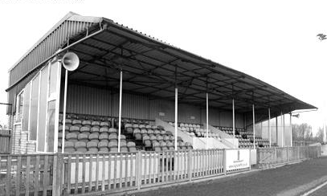
The new ground, also called Honeycroft was first visited by us on 4th February 1986, nine years after we had met in the League Cup Quarter Final. The circumstances were eerily similar as this meeting was also in the Quarter-Final of a League Cup, this time under the auspices of the Isthmian League. Again the first match was drawn after extra time and again the home team won the replay, going on to reach the Final as we had done the previous time.

This was disappointing as we were an Isthmian League Premier Division club back then, but not for much longer and in our fleeting season in Division One before relegation we met twice in league action, drawing 2-2 at Honeycroft in a match where we started with nine men and recovered a 2-0 deficit, before our final meeting on 31st March 1987 when Uxbridge defeated us 2-0 at West Street.

They remained one flight below the Premier Division until 2004 when F.A. reorganisation moved them into the Southern League where they remain to this day as a barometer Step Four club. Their last promotion came in 1985. How dull!

The main stand at the new Honeycroft

Player Sponsorship
Here is the current list for the 2016/17 season showing all of our players and Management that are available for sponsorship.

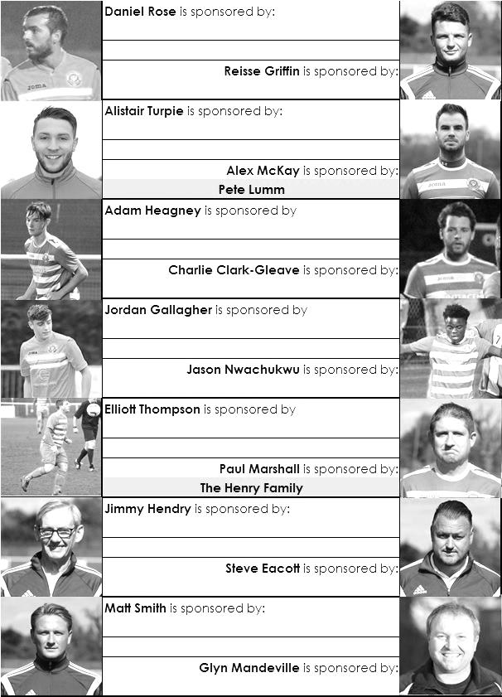

Sponsorship costs just £40 and it is easy to do. Just select a player who has not been previously sponsored and let a Committee Member know that you would like to sponsor them. Beware though. Until we have received the money it is possible for someone to jump in front of you, so don’t delay, sponsor today!
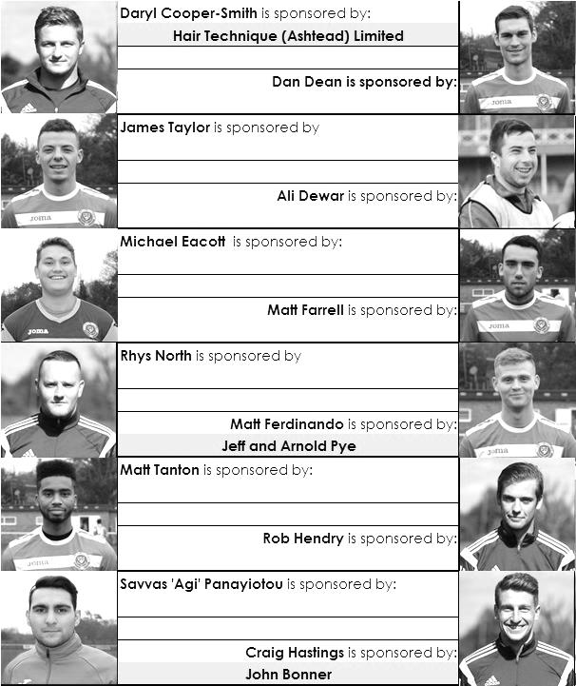

Match and Ball Sponsorships – 2016/17
Opponent | Date | Match Sponsor | Ball Sponsor
Gravesham Borough | 07/08/16 | Club President - Stella Lamont
Gravesham Borough | 07/08/16 | Relocation Committee Member - Mike Lovett
CB Hounslow United | 16/08/16 | EEFC Management Committee
Abbey Rangers | 23/08/16 | Steve & Geoff Dyke
Horley Town (11.30am) | 29/08/16 | In Memory of Chris Henry
Abbey Rangers (LC) | 06/09/16 | Paul Merritt
Camberley Town | 10/09/16 | Building Shop Ltd
Knaphill | 24/09/16 | EEFC Holding Company Director – Pete Lumm
Bridon Ropes (FAV) | 22/10/16 | George and Joseph Saunders
Sutton Common Rovers | 08/11/15 | Alex McKay Senior
Abbey Rangers (FAV) | 13/11/16 | EEFC Holding Company Director – Dave Ellins
Windsor | 15/11/16 | In Memory of Wally Dyke
Bedfont Sports | 19/11/16 | John Bonner
AFC Hayes | 26/11/16 | Jack Jarman
Chipstead (SSC / DWT) | 06/12/16 | Trevor Stotten
Hanworth Villa | 13/12/16 | Roger and Carol Farrell
Chertsey Town | 17/12/16
Raynes Park Vale (11.30am) | 27/12/16 | In memory of Dave and Liz Marshall
Spelthorne Sports | 07/01/17 | Building Shop Ltd
Guildford City (SSC) | 10/01/17 | Super Six Winner – Rita Christian
Guildford City | 17/01/17
Bedfont & Feltham | 21/01/17 | Programme Editor - Richard Lambert
Badshot Lea | 04/02/17
Westfield | 18/02/17
Walton & Hersham | 04/03/17
Hartley Wintney | 18/03/17
Farnham Town | 25/03/17
Colliers Wood United (1pm) | 14/04/17 | Good Friday match – make a note!
North Greenford United | 22/04/17 | Club President - Stella Lamont
For League, League Cup and Surrey Senior Cup Matches:
Match sponsorship - £40.00 Match ball sponsorship - £25.00. Combined £55.00.
For F.A. Cup and F.A. Vase matches:
Match sponsorship - £50.00 Match ball sponsorship - £30.00. Combined £65.00.

Sponsorship includes: (x2 for match, x3 for match and ball)

Admission, programmes, hospitality and advertising and mascot for the day (if required).
If you are interested, just speak to a Committee Member, or drop me an email at: richard.c.lambert@gmail.com

We also thank our Sponsors INTERCEM and G4 Group

Salts Super Six Predictor
The Salts Super Six Predictor is live again for today’s match and the tickets are on sale at today’s game to the left of the gate. The matches are to be played today.

The jackpot is already up to £339 so what are you waiting for!

The competition is easy to play! To win, you simply need to predict the results of six matches correctly from the three options, fill in the form and make sure it is back with our seller before the deadline on the ticket. The latest fixtures are shown below.

If you are a club regular, you just need to place your name on the sheet, although if you aren’t, then we’ll need a contact number from you too. We will announce any winners on the website within three working days, so don’t worry, we won’t miss you!

Please note that if there is more than one winner, the prize pot would be shared between the winners. All you need to do now is have a go, as many times as you like!

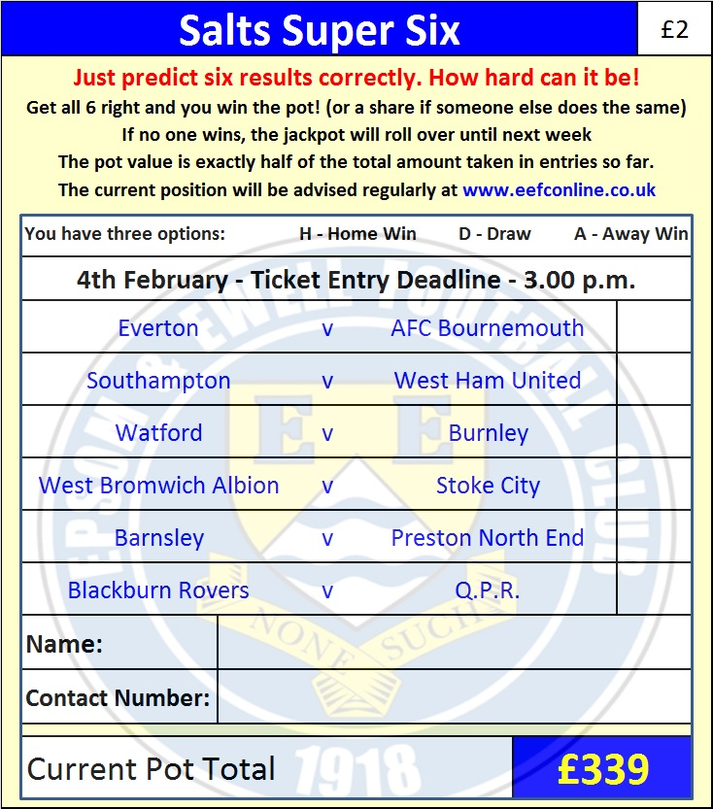
Good luck!

Combined Counties League – Premier Division
Saturday, 4th February 2017 - Kick-off 3.00 p.m.

Epsom and Ewell  (Royal Blue & White hoops) | V |  | Badshot Lea  (Claret and Blue)
Squad | NUMBERS |  | Squad
Michael Eacott |  |  | Pat Kinsella
Adam Heagney |  |  | Freddie Gee
Matt Tanton |  |  | Jubril Borishade
James Taylor |  |  | Craig Wright
© Dan Dean |  |  | Josh Pound
Savvas ‘Agi’ Panayiotou |  |  | Ethan Allen
Jordan Gallagher |  |  | Peter Millington-Lee
Matt Farrell |  |  | Ross Wickens
Rob Hendry |  |  | Gac Muir
Matt Ferdinando |  |  | James Pilgrim
Reisse Griffin |  |  | Rob Webb
Jason Nwachukwu |  |  | Cameron Blackie
Craig Hastings |  |  | Euan Aitchison
Daryl Cooper-Smith |  |  | Ryan Scott
Alex McKay |  |  | Oli Graham
Daniel Rose |  |  | Macauley Ford
Alistair Turpie |  |  | Richie Hunter
Charlie Clark-Gleave |  |  | Ian Brooks
Matt Smith |  |  | Ross Frisby
Ali Dewar |  |  | Brad Smith
 |  |  | Darren Blake
 |  |  | Matt Stamp
Glyn Mandeville | MANAGER |  | Michael Charles
Matt Smith | ASSISTANT |  | Darryl Jelly
Steve Eacott / Alex McKay /  Jimmy Hendry | COACHES / PHYSIO |  | Nick Sowden
REFEREE: P.Georgiou
ASSISTANTS: R.Ilev, K.Parker

OUR NEXT VISITORS TO HIGH ROAD
Westfield
Combined Counties League – Premier Division
Saturday 18th February 2017 – 3.00 p.m.

